WaterApp Questions Data

Question 1: Dishwashing
Category: DISHWASHING Question: Do you use a dishwasher to wash your dishes? Training Text: Hand washing dishes can use up to 5 times more water compared to using a dishwasher. Content Message: Switch to a dishwasher and save both water and time! Image: dishwasher.jpg Video: https://www.youtube.com/watch?v=PUCk6mMAZNA Additional Info: Studies suggest that using a dishwasher uses 73% less water than washing dishes by hand
Options:
- Yes
  - Value Saving: 111
  - Value Total: 15
  - Task Message: Well done, you've saved time & 15 litres of water
  - Type: Achievement
- No
  - Value Saving: 0
  - Value Total: 126
  - Task Message: Pre-rinsing dishes wastes 1,232 litres of water a year
  - Type: Task

Question 2: Pre-rinsing
Category: DISHWASHING Question: Do you pre-rinse your dishes before stacking them in the dishwasher? Training Text: Pre-rinsing dishes may not always be necessary and can lead to a lot of water wastage. Content Message: Modern dishwashers are designed to handle tough food residues Image: pre-rinse.jpg Video: https://www.youtube.com/watch?v=5si55pHkDIk Additional Info: Modern dishwashers do not need plates and dishes to be rinsed
Options:
- Yes
  - Value Saving: 0
  - Value Total: 36
  - Task Message: Do you need to rinse? Act accordingly!
  - Type: Task
- No
  - Value Saving: 21
  - Value Total: 15
  - Task Message: Well done for saving water!
  - Type: Achievement

Question 3: Load Size
Category: DISHWASHING Question: Do you run your dishwasher on a full or half load cycle? Training Text: Maximizing the load of your dishwasher before running can lead to significant water savings over time. Content Message: Make every drop count! Wait for a full load Image: full-load.jpg Video: https://www.youtube.com/watch?v=DX8jpet6Q_k Additional Info: A half-loaded dishwasher uses nearly the same amount of water as a full load
Options:
- Full
  - Value Saving: 11
  - Value Total: 22
  - Task Message: Your making a positive change by fully loading your dishwasher - Well done!
  - Type: Achievement
- Half full
  - Value Saving: 0
  - Value Total: 22
  - Task Message: Did you know, a fully loaded dishwasher will save you 11 liters. Please take necessary action!
  - Type: Task

Question 4: Flow Regulators
Category: PLUMBING Question: Are the taps in your home fitted with flow regulators ("aerators")? Training Text: Regular taps can use up to twice as much water as their low-flow counterparts. Content Message: Every drop counts! Switch to low-flow taps Image: aerator.jpg Video: https://www.youtube.com/watch?v=fFQiIU_zJ5U Additional Info: Upgrading to low-flow taps is a cost-effective way to conserve water
Options:
- Yes
  - Value Saving: 44
  - Value Total: 76
  - Task Message: That's great - your saving over 8 litres of water a minute
  - Type: Achievement
- No
  - Value Saving: 0
  - Value Total: 120
  - Task Message: Did you know, aerators can use less than 800ml of water. Please take necessary action and save money.
  - Type: Task

Question 5: Shower Duration
Category: SHOWER Question: How long does it take you to take shower? Training Text: Every additional minute in the shower uses up to 5 gallons of water. Content Message: Time to reflect! Can you cut down a few minutes? Image: shower-timer.jpg Video: https://www.youtube.com/watch?v=v-TwsMtvw7w Additional Info: By reducing your shower time you save water and energy
Options:
- Under 5 mins
  - Value Saving: 160
  - Value Total: 70
  - Task Message: 5 minutes shower is the target and it is a hard challenge, congratulations!
  - Type: Achievement
- 5 - 10 mins
  - Value Saving: 80
  - Value Total: 150
  - Task Message: Decreasing your shower duration makes a significant difference, take the necessary action!
  - Type: Task
- 11 - 15 mins
  - Value Saving: -20
  - Value Total: 250
  - Task Message: Decreasing your shower duration makes a significant difference, take the necessary action!
  - Type: Task
- Over 15 mins
  - Value Saving: -220
  - Value Total: 450
  - Task Message: Decreasing your shower duration makes a significant difference, take the necessary action!
  - Type: Task
- Use a bucket
  - Value Saving: 210
  - Value Total: 20
  - Task Message: Bucket usage is the target and it is a hard challenge, congratulations!
  - Type: Achievement

Question 6: Laundry Load
Category: LAUNDRY Question: Do you run your laundry on a full load or half full load? Training Text: Washing half loads frequently can lead to more water usage over time. Content Message: Plan ahead! Combine your laundry to make full loads Image: laundry.jpg Video: https://www.youtube.com/watch?v=An-TW6tZd0o Additional Info: Running your machine with full loads extends its life
Options:
- Full
  - Value Saving: 90
  - Value Total: 180
  - Task Message: By full loading your laundry you save 90 liters water, congratulations!
  - Type: Achievement
- Half full
  - Value Saving: 0
  - Value Total: 180
  - Task Message: 90 liters more with full loaded laundries, take the necessary action!
  - Type: Task

Question 7: Teeth Brushing
Category: DAILY Question: Do you turn off the water while you brush your teeth? Training Text: Turning off the water while brushing can save significant amounts over time. Content Message: Save 12 litres by turning off the tap while brushing Image: brushing.jpg Video: https://www.youtube.com/watch?v=gtcZbN0Z08c Additional Info: Small changes in daily habits can lead to big savings
Options:
- Yes
  - Value Saving: 2
  - Value Total: 2
  - Task Message: You saved 10 liters for your each brush, congratulations!
  - Type: Achievement
- No
  - Value Saving: 0
  - Value Total: 4
  - Task Message: Turn off the water and save 10 liters more for your each brush, take the necessary action!
  - Type: Task

Question 8: Eco mode on appliances
Category: APPLIANCES Question: Do you use eco-mode on house appliances such as dishwasher and washing machine? Training Text: Using eco-mode can save 20% water for dishwasher and 50% for washing machines (on average). Content Message: If your appliances has the choice of eco-mode, always opt for that!
Image: 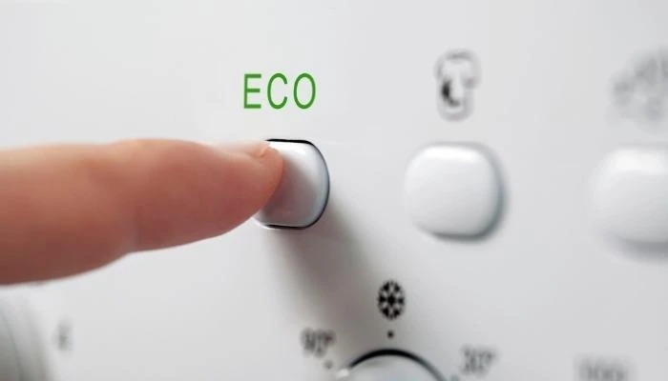
Video: https://youtu.be/vsVcLK4fRGI?si=hvrXsoCp2b5dJI1T [need to search to find something better – to ask the other champions]

Additional Info: If your dishwasher or washing machine does not have the eco-mode, focus on full load as a minimum.
Options:
- Yes
  - Value Saving: [4,500 litres/ per year]
  - Value Total: [10,050 litres / year]
  - Task Message: Good job, keep using the eco-mode!
  - Type: Achievement
- Sometimes
  - Value Saving: [2,250 litres / per year]
  - Value Total: [10,050 litres / year]
  - Task Message: Try and use eco-mode always.
  - Type: Task
- No
  - Value Saving: 0
  - Value Total: 10,050 litres/ year
  - Task Message: Change to eco-mode and save 50% for washing machine and 20% for dish washer!
  - Type: Task

Question 9: Car Washing
Category: Car Question: Do you manually wash your car or do you use pressure washer system? Training Text: Professional car washes typically use less water than manual washing. Content Message: Save water while keeping your car clean Image: pressure-wash.jpg Video: https://www.youtube.com/watch?v=RoQRdHF2qgI Additional Info: Use water-efficient methods for vehicle cleaning
Options:
- Yourself
  - Value Saving: 0
  - Value Total: 200
  - Task Message: 120 liters more with each car wash, take the necessary action!
  - Type: Task
- A professional car cleaning service
  - Value Saving: 120
  - Value Total: 80
  - Task Message: Washing your car by pressure washer systems you saved 120 liters water, congratulations!
  - Type: Achievement
- Don’t have a car
  - Value Saving: 0
  - Value Total: 0
  - Task Message: none
  - Type: Achievement

Question 10: Gardening
Category: Garden Question: Do you use rain water when watering the garden or your indoor plants? Training Text: You can save a significant amount of water by using rainwater for your garden, potentially replacing 40–50% of your mains water usage for outdoor and indoor non-potable needs. Content Message: Save water while keeping your garden beautiful.
Image: 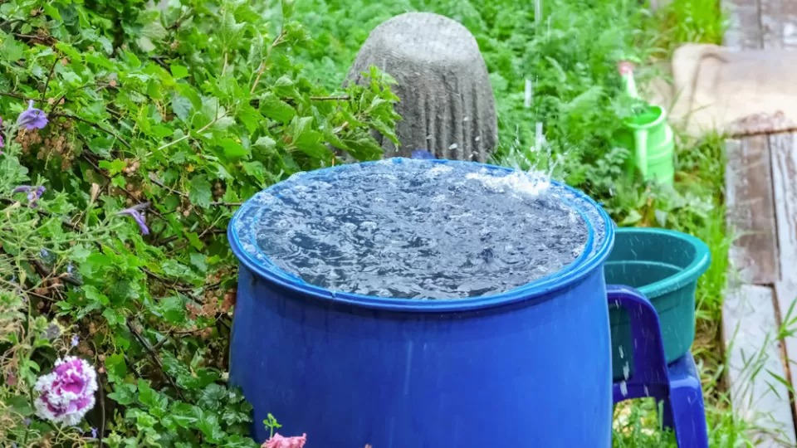
Video: https://youtu.be/tgophFI451Y?si=SAytE7S269VxJ5k3
Additional Info: Use water-efficient methods for your garden and indoor plants.
Average water usage for gardening:
- A typical UK household uses about 5,000–10,000 litres/year for outdoor watering.
- Indoor plant watering might add 500–1,000 litres/year.
Options:
- Yes
  - Value Saving: [4,000–5,000 litres/year saved]
  - Value Total: [10,000 litres/year]
  - Task Message: Well done, you potentially replacing 40–50% of your mains water usage for outdoor and indoor non-potable needs.
  - Type: Achievement
- No
  - Value Saving: [0]
  - Value Total: [10,000 litres/year ]
  - Task Message: Collecting rain water and watering your garden and indoor plants can replace 40-50% of your main usage for outdoor and indoor non-potable needs.
  - Type: Task
- Don’t have a garden
  - Value Saving: 0
  - Value Total: 0
  - Task Message: none
  - Type: Achievement

Question Template and Calculation Guide

Empty Question Template
## Question [NUMBER]: [SHORT_TITLE]
**Category:** [CATEGORY_ID from categories(below, select only one of them)]
**Question:** [Your question text here]
**Training Text:** [Educational text about the topic]
**Content Message:** [Brief motivational message]
**Image:** [attach your image, (optional) image_name.jpg]
**Video:** [YouTube URL]
**Additional Info:** [Detailed information about the topic]

Options:
1. **[Option 1 Text]**
- Value Saving: [Water saved in liters, positive for good habits]
- Value Total: [Total water usage in liters]
- Task Message: [Motivational message based on choice]
- Type: [Achievement/Task/null]

2. **[Option 2 Text]**
- Value Saving: [Water saved in liters]
- Value Total: [Total water usage in liters]
- Task Message: [Motivational message based on choice]
- Type: [Achievement/Task/null]

Value Calculation Guidelines

Value Total (Water Usage)
- Must be a positive number
- Represents the total water usage for this behavior
- Examples:
  - Dishwasher: ~15L per cycle
  - Manual washing: ~126L per load
  - 5-min shower: ~70L
  - 15-min shower: ~250L
  - Tap with aerator: ~76L per day
  - Tap without aerator: ~120L per day
  - Full laundry load: ~180L
  - Car manual wash: ~200L
  - Car pressure wash: ~80L

Value Saving (Water Savings)
- Can be positive or negative
- Positive: indicates water saved compared to worst option
- Negative: indicates additional water used compared to best option
- Calculate as: Best practice usage - Current usage
- Examples:
  - Dishwasher vs Manual: 126L - 15L = 111L saving
  - 5-min vs 15-min shower: 250L - 70L = 180L saving
  - Aerator vs No aerator: 120L - 76L = 44L saving

Type Guidelines
- Achievement Type
  - Best practice behaviors
  - Usually has positive Value Saving
  - Used when the behavior is optimal
  - Examples:
    - Using dishwasher (saves water vs manual)
    - Short showers (saves water vs long showers)
    - Using aerators (saves water vs regular taps)
- Task Type
  - Behaviors that need improvement
  - Usually has 0 Value Saving
  - Used when there's room for improvement
  - Examples:
    - Manual dish washing
    - Long showers
    - No aerators installed
- null Type
  - Used for filtering questions only
  - Both Value Saving and Value Total are 0
  - No Task Message needed
  - Examples:
    - Vehicle ownership question
    - Appliance ownership questions

Task Message Guidelines
- For Achievements:
  - Use congratulatory tone
  - Mention specific water savings
  - Keep it positive and motivating
  - Examples:
    - "Well done, you've saved X litres of water!"
    - "Great job! You're saving X liters per [time period]"
    - "Congratulations on saving X liters by [action]!"
- For Tasks:
  - Use encouraging tone
  - Mention potential savings
  - Include "take the necessary action"
  - Make it educational
  - Examples:
    - "You could save X liters by [action]. Please take necessary action!"
    - "Did you know you can save X liters by [action]? Take the necessary action!"
    - "X liters more with [current behavior], take the necessary action!"

Categories
Remember to use only these predefined categories:
- DISHWASHING: Dishwasher usage, washing habits
- SHOWER: Shower duration, bathing methods
- LAUNDRY: Washing machine usage, load sizes
- PLUMBING: Taps, pipes, water fixtures
- DAILY: Regular habits like teeth brushing
- CAR: Vehicle cleaning methods

Image and Video Guidelines
- Images should be relevant and clear
- Attach images with your email. (optional)
- Use .jpg or .png format
- Videos should be educational
- Prefer short, focused video content
- Use YouTube URLs for videos

